Description
The Electronic & Computer Engineering Technology (ECET) program leads to an Associate in Science degree and provides students with the skills and knowledge required for entry level employment within high-technology industry as electronic / electro-optic technicians, renewable energy technicians, telecom technicians, and network system administrators. Students learn fundamental engineering concepts, computer programming, mathematics, and physics relevant to a wide variety of industries on Maui. Training, equipment, and supplies are provided for 3-D printing and circuit board fabrication. Software applications for circuit simulation, CAD, finite element analysis, and microprocessor control are utilized. The program requires written and verbal proficiencies and emphasizes laboratory competencies. Internship and job placement opportunities in a variety of engineering technology positions are provided.
Mission Statement
The mission of the ECET program is to provide students with relevant and rigorous training and education needed for entry-level engineering technology positions in Maui County and to give graduates mobility within the field and the ability to adapt as the field changes.
The ECET program works closely with its high-technology industry advisory board to ensure students gain skills required for employment with local companies. In this respect, the program builds upon skills, duties and tasks considered critical by these prospective employers.

DESCRIPTION TAB
  - Demand Indicators: Unhealthy
The demand indicator, which states that the program is unhealthy, is based on the number of new and replacement positions in the state (68) and county prorated (6): New and replacement positions/ Number of AS ECET graduates = 6/7= .8, which calls for a Cautionary indicator.

b. Efficiency Indicators: Cautionary
Table 1 below shows the number of active students enrolled in the ECET program in fall 2017 and spring 2018 (The number in parenthesis represents the cohort, i.e., the year students enrolled in ETRO 105). An active ECET student is a student who is/has been enrolled in ETRO 105, the entry-level ECET course. However students who identify themselves as ECET majors (67 according to the system) are not all real ECET students: they are not enrolled in courses that prepare them for the ECET program. As a consequence, the ratio of majors to FTE BOR appointed faculty does not represent the reality. The retention rate fall to spring is 82%.

Table 1. ECET active students enrollment, fall 2017 to spring 2018
Fall 2017 |  | Spring 2018
ECET active students
year 1 (2017) | 18 | year 1 (2017) | 14
year 2 (2016) | 5 | year 2 (2016) | 5
year 3 (2015) | 1 | year 3 (2015) | 1
year 4 (2014) | 3 | year 4 (2014) | 2
year 5 (2013) | 1 | year 5 (2013) | 1
Total ECET | 28 | Total ECET | 23

c. Effectiveness Indicators: Cautionary
See Table 1 for retention rate fall to spring. On the other hand, 7 students graduated with the AS in spring 2018, out of which 60% earned the AS degree in two years.
Perkins Indicators not met: The actual indicators are based on the number of students who declare ECET as their major. As explained above, only a fraction of these students are actively enrolled in ETRO courses required for the ECET program.
ANALYSIS TAB
- Analysis of the Program
- Briefly discuss any new significant program actions (new certificates, stopout, gain or loss of positions) as results of last year’s action plan.
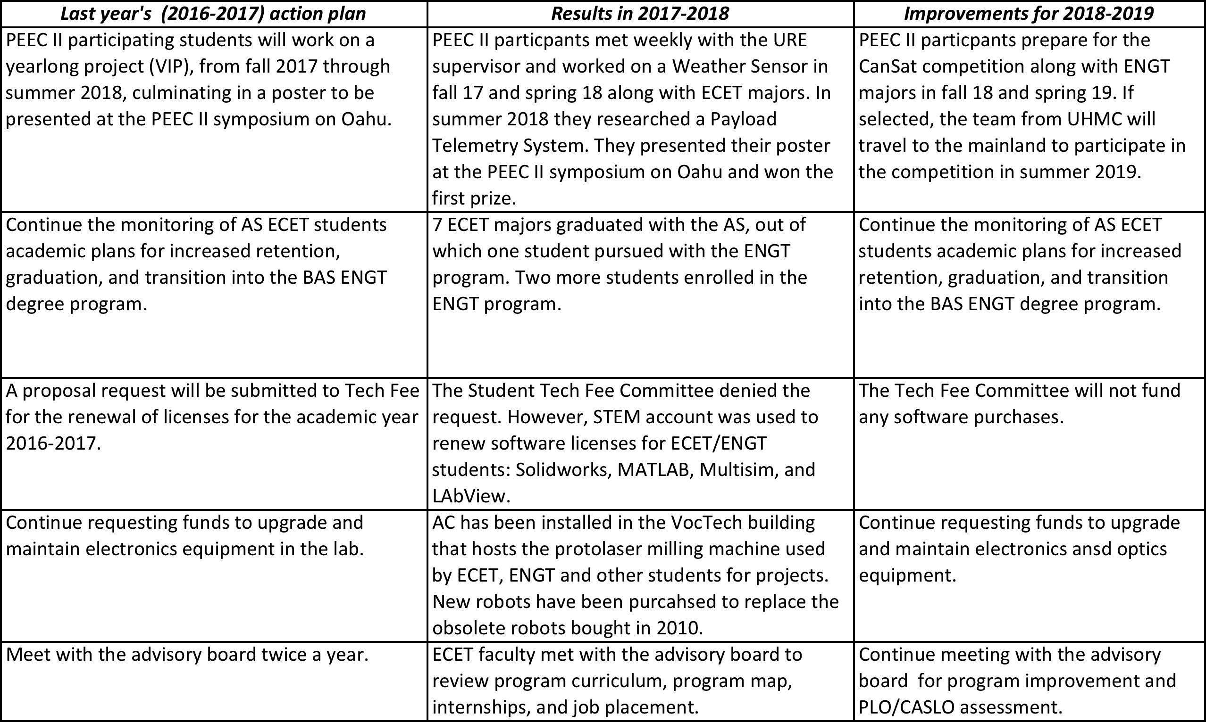

- If relevant, share a brief analysis for any Perkins Core Indicator not met.
- Goals and/or actions from previous assessment results
- Describe results from previous assessment goal and/or action implementation

  - PLO: No PLOs were assessed

  - CASLO: Creativity was assessed in ETRO 296, Special Projects in Electronics.

P-SLOs TAB
- PLO selected for assessment (click on the PLO assessed – it will turn green).
No PLOs were assessed during this time period.

- Industry Validation (check all that apply):
Advisory Committee Meeting(s) X , How many? 1
Did Advisory Committee discuss CASLO/PLO? NO/YES
Coop Ed Placements X, Fund raising activities/eventsX, Service Learning __
Provide program services that support campus and/or community X
Outreach to public schools X
Partner with other colleges, states and/or countries (working on this)
Partner with businesses and organizations X
Other X Describe: ENGT Students Capstone Projects Exhibition, April 2018

- Expected level of Achievement:
- Courses (or assignments) Assessed:

- Assessment strategy/Instrument/Evidence (check all that apply):
Work Sample__ Portfolio__ Project __ Exam __ Writing Sample __
Other Please explain:

- Results of program assessment:
a. The following were present at the PLO assessment:
JD Armstrong (IfA)
Ned Davis (Maui Innovation Group)
Steve Griffin (Boeing)
Joseph Janni (UTC/AFRL)
Laura Ulibarri (Air Force
John Valliant (Boeing)
Elisabeth Dubuit (ECET/ENGT faculty)
Mark Hoffman (ECET faculty)
Jung Park (ECET/ENGT faculty)

b. Strengths and weaknesses (best practices and educational gaps) found from PLO assessment analysis:

- Other comments:
Describe CASLO assessment findings and resulting action plans. Go to Laulima UHMC CASLO Assessment for your program’s “Assessment results” and summarize below.
ETRO 296, Special Projects in Electronics, was used to assess the CASLO “Creativity”. There is no assessment report for this CASLO.
- Next steps:
For program learning outcomes (check all that apply):
Assess the next PLO_X Review PLOsX Adjust assignment used for PLOX
Adjust course used for PLOX_ Meet with Advisory CommitteeX
Other___ Please explain:

- Please list any professional development needs you may have for your program.

